Terraform Final Task
1. Create VPC
2. Create Internet gateway
3. Create Custom Route Table
4. Create Subnet
5. Associate subnet with Route Table
6. Create Security Group to allow port 22.80,443
7. Create a network interface with an ip in the subnet that was created in step 4
8. Assign an elastic IP to the network interface created in step 7
9. Create Ubuntu server and install/enable apache2
We will use Ubuntu Server, because Step 9 specifically requires installing apache2.
1. Create Terraform folder
Open PowerShell:
cd C:\Desktop
mkdir terraform-finaltask
cd terraform-finaltask
code .
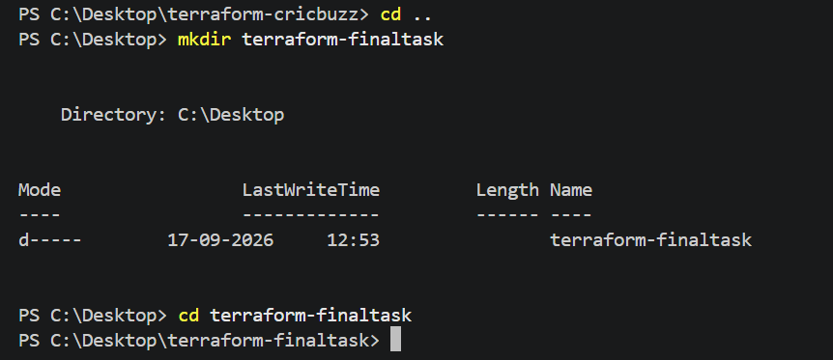
Create these files: terraform-final-task
│
├── provider.tf
├── variables.tf
├── vpc.tf
├── subnet.tf
├── route.tf
├── security-group.tf
├── network-interface.tf
├── elastic-ip.tf
└── ec2.tf
Step 1 — Create VPC
Purpose
Create an isolated AWS network.
vpc.tf
resource "aws_vpc" "main" {
cidr_block = "10.0.0.0/16"
tags = {
Name = "terraform-vpc"
}
}
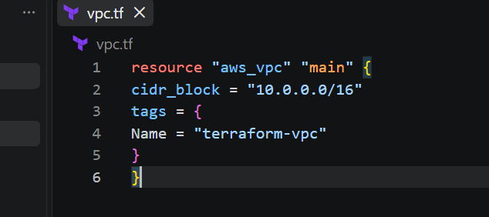
Step 2 — Create Internet Gateway
Purpose
Allow the VPC to communicate with the internet.
Add this to vpc.tf:
resource "aws_internet_gateway" "igw" {
vpc_id = aws_vpc.main.id
tags = {
Name = "terraform-igw"
}
}
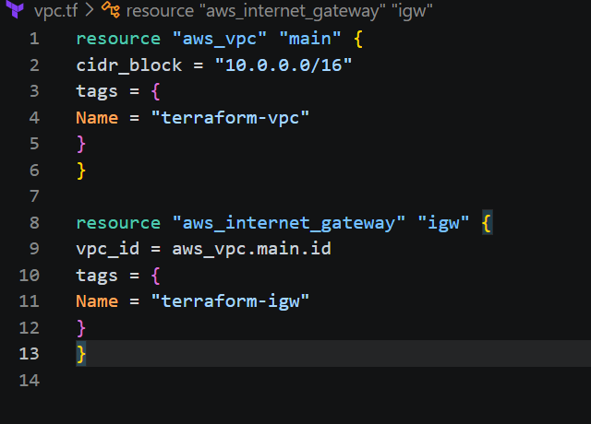
Step 3 — Create Custom Route Table
Purpose
Send internet traffic through the Internet Gateway.
route.tf
resource "aws_route_table" "public" {
vpc_id = aws_vpc.main.id
route {
cidr_block = "0.0.0.0/0"
gateway_id = aws_internet_gateway.igw.id
}
tags = {
Name = "terraform-public-route"
}
}
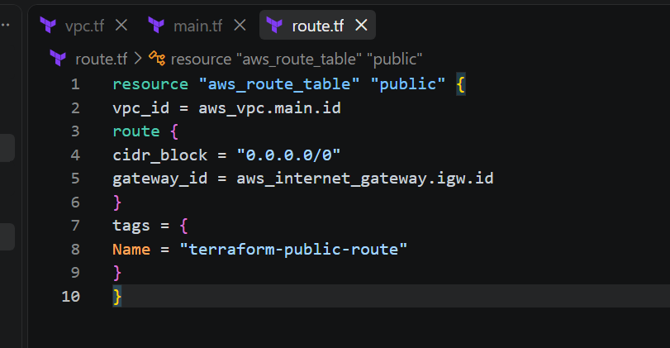
Step 4 — Create Subnet
Purpose
Create a subnet inside the VPC for the EC2 server.
subnet.tf
resource "aws_subnet" "public" {
vpc_id = aws_vpc.main.id
cidr_block = "10.0.1.0/24"
availability_zone = "us-east-1a"
tags = {
Name = "terraform-public-subnet"
}
}
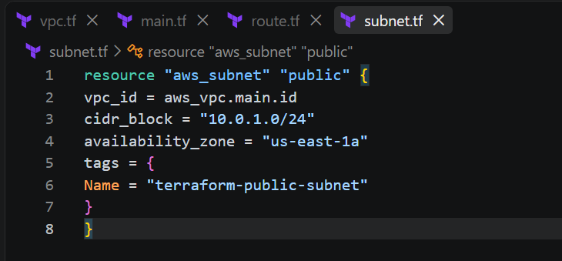
Step 5 — Associate Subnet with Route Table
Purpose
Connect the subnet to the custom route table.
Add to route.tf:
resource "aws_route_table_association" "public" {
subnet_id = aws_subnet.public.id
route_table_id = aws_route_table.public.id
}
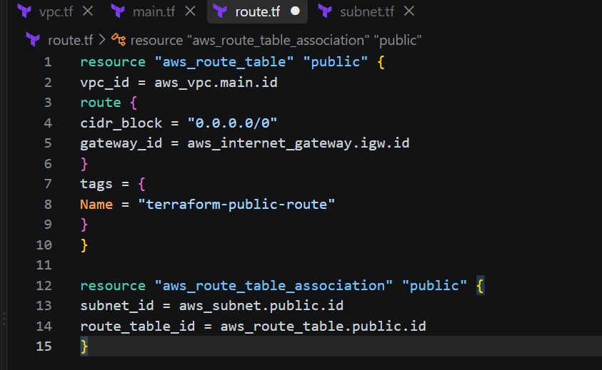
Step 6 — Create Security Group
Purpose
Allow SSH, HTTP and HTTPS traffic.
security-group.tf
resource "aws_security_group" "web" {
name = "terraform-web-sg"
vpc_id = aws_vpc.main.id
ingress {
description = "SSH"
from_port = 22
to_port = 22
protocol = "tcp"
cidr_blocks = ["0.0.0.0/0"]
}
ingress {
description = "HTTP"
from_port = 80
to_port = 80
protocol = "tcp"
cidr_blocks = ["0.0.0.0/0"]
}
ingress {
description = "HTTPS"
from_port = 443
to_port = 443
protocol = "tcp"
cidr_blocks = ["0.0.0.0/0"]
}
egress {
from_port = 0
to_port 0
protocol = "-1"
cidr_blocks = ["0.0.0.0/0"]
}
tags = {
Name = "terraform-web-sg"
}
}
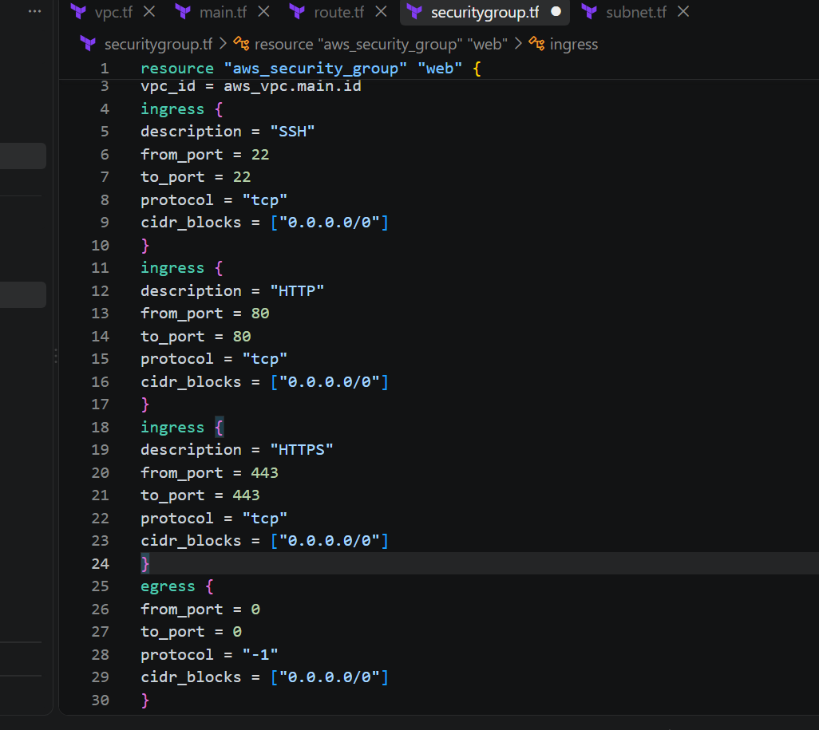
For a real production server, restrict port 22 to your trusted IP instead of 0.0.0.0/0.
Step 7 — Create Network Interface
Purpose
Create an ENI with a private IP inside the subnet.
network-interface.tf
resource "aws_network_interface" "web" {
subnet_id = aws_subnet.public.id
private_ips = ["10.0.1.10"]
security_groups = [
aws_security_group.web.id
]
tags = {
Name = "terraform-web-eni"
}
}
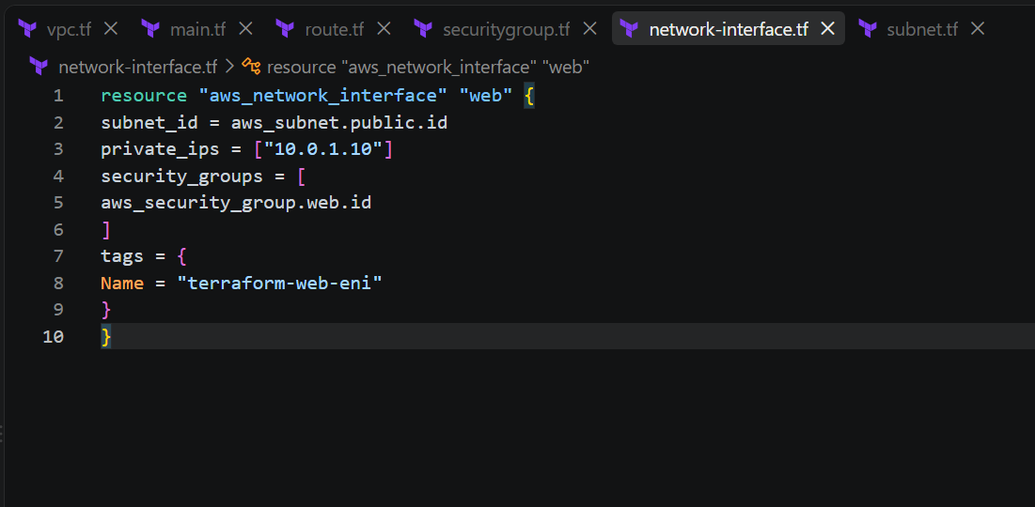
Step 8 — Assign Elastic IP
Purpose
Give the network interface a public static IP.
elastic-ip.tf
resource "aws_eip" "web" {
domain = "vpc"
network_interface = aws_network_interface.web.id
depends_on = [
aws_internet_gateway.igw
]
tags = {
Name = "terraform-web-eip"
}
}
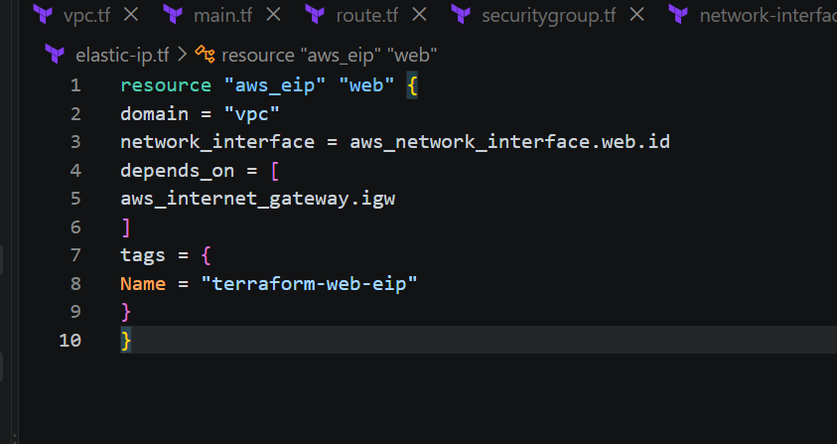
Step 9 — Create Ubuntu Server and Install Apache2
Purpose
Create an Ubuntu EC2 server and install/enable Apache2.
variables.tf
variable "region" {
default = "us-east-1"
}
variable "instance_type" {
default = "t2.micro"
}
variable "key_name" {
default = "linux-key"
}
variable "ami_id" {
description = "Ubuntu AMI ID"
default = "YOUR-UBUNTU-AMI-ID"
}
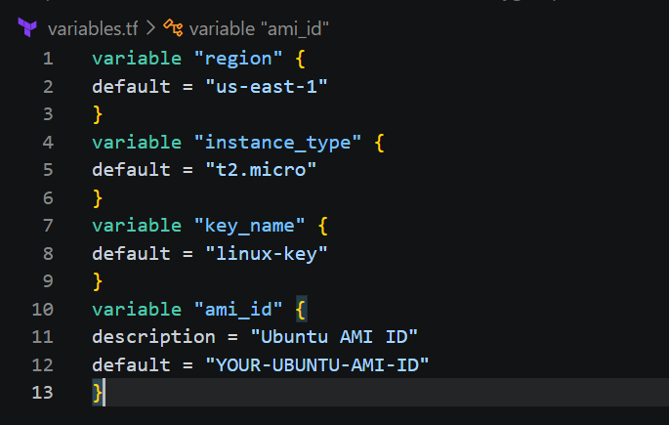
main.tf
provider "aws" {
region = var.region
}
resource "aws_instance" "web" {
ami = var.ami_id
instance_type = var.instance_type
key_name = var.key_name
network_interface {
network_interface_id = aws_network_interface.web.id
device_index = 0
}
user_data = <<-EOF
#!/bin/bash
apt update -y
apt install -y apache2
systemctl enable apache2
systemctl start apache2
echo "Hello from Terraform Apache Server" > /var/www/html/index.html
EOF
tags = {
Name = "terraform-apache-server"
}
depends_on = [
aws_eip.web
]
}
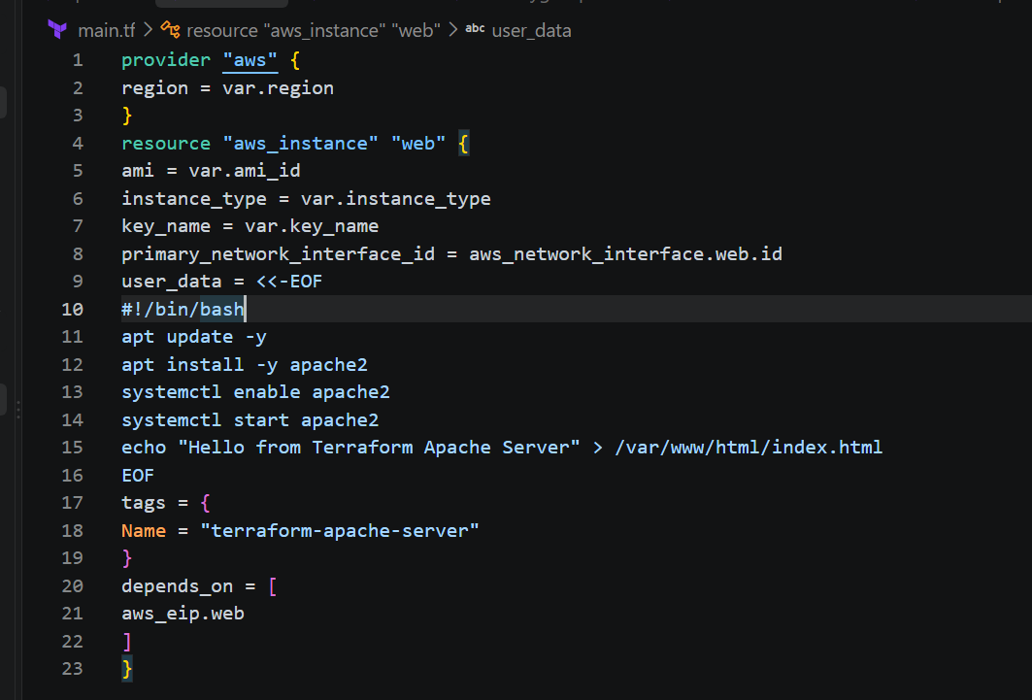
Execute Terraform
Step 10 — Initialize Terraform
In VS Code terminal: terraform init
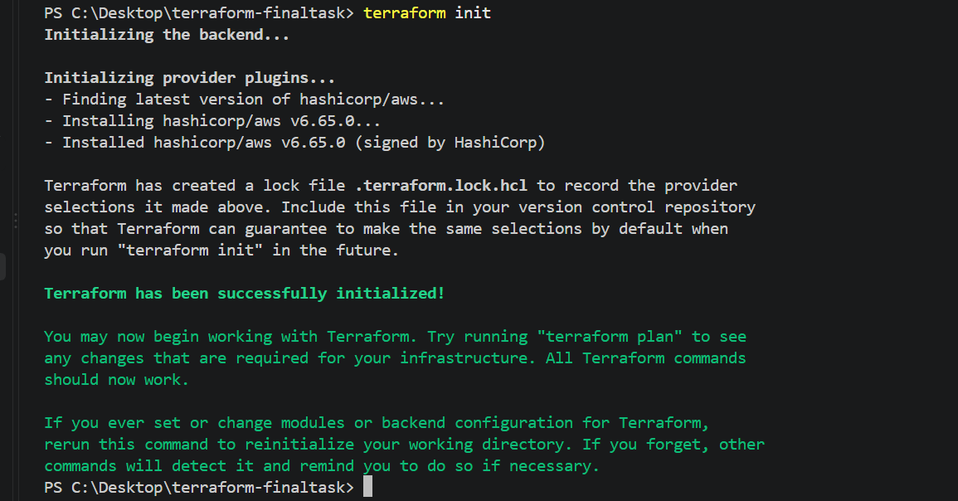
Step 11 — Format
terraform fmt
Purpose
Automatically formats all .tf files.
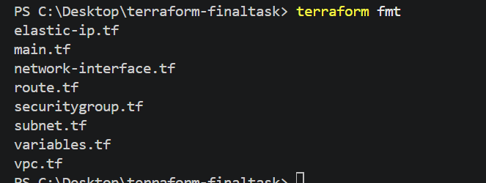
Step 12 — Validate
terraform validate
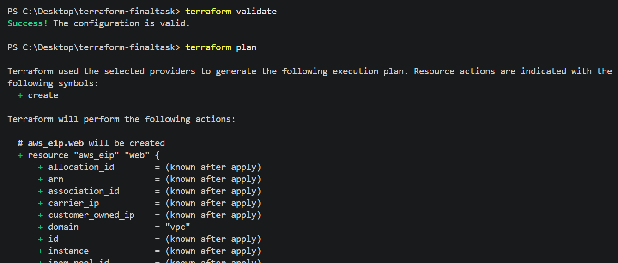
Step 13 — Plan
terraform plan
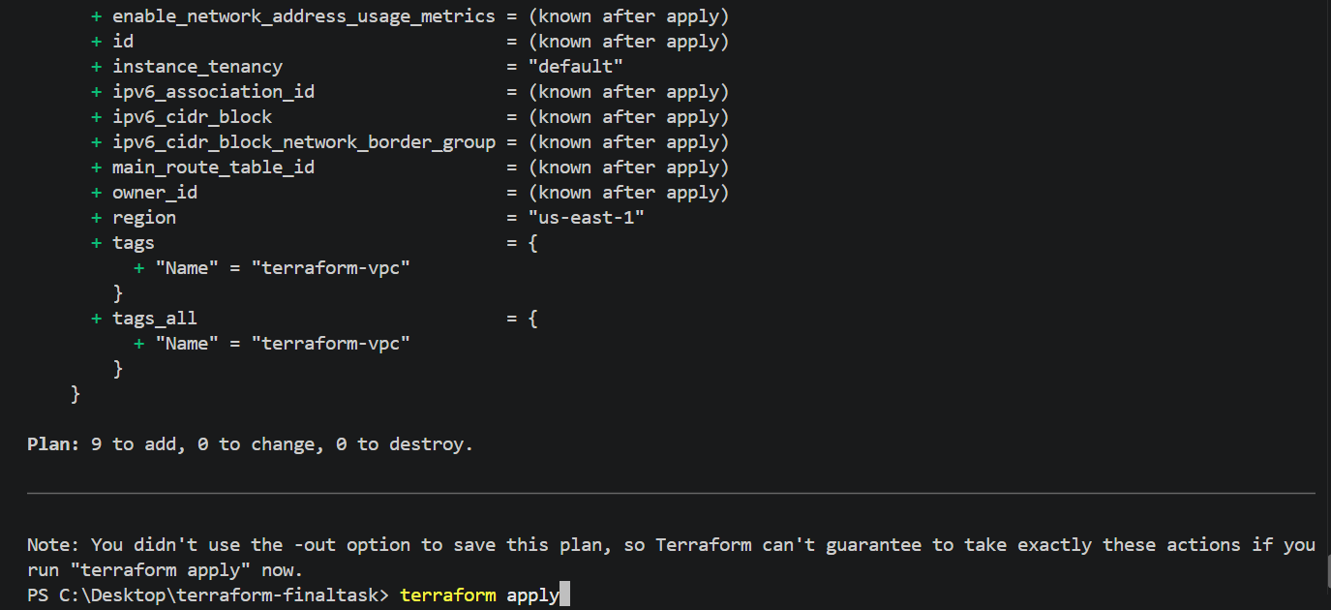
Step 14 — Apply
terraform apply
When prompted: Enter a value: yes
Terraform will create all resources.
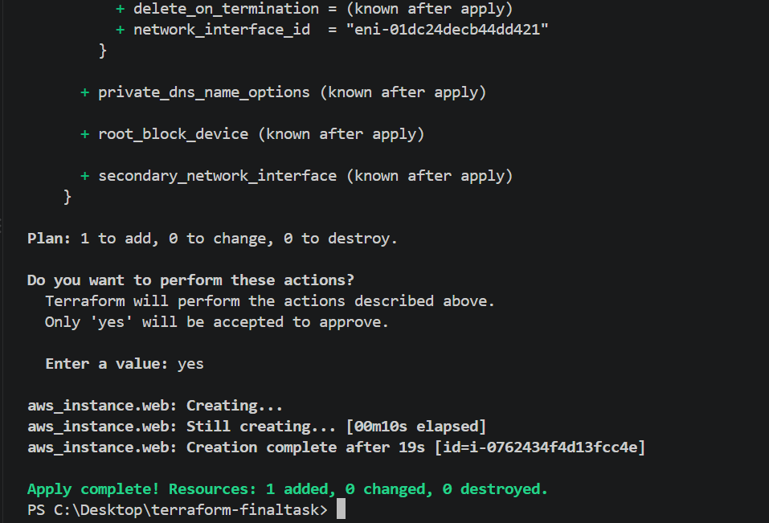
Verify
SSH Verification
For Ubuntu: ssh -i C:\Users\sriva\Downloads\linux-key.pem ubuntu@<ELASTIC-IP>
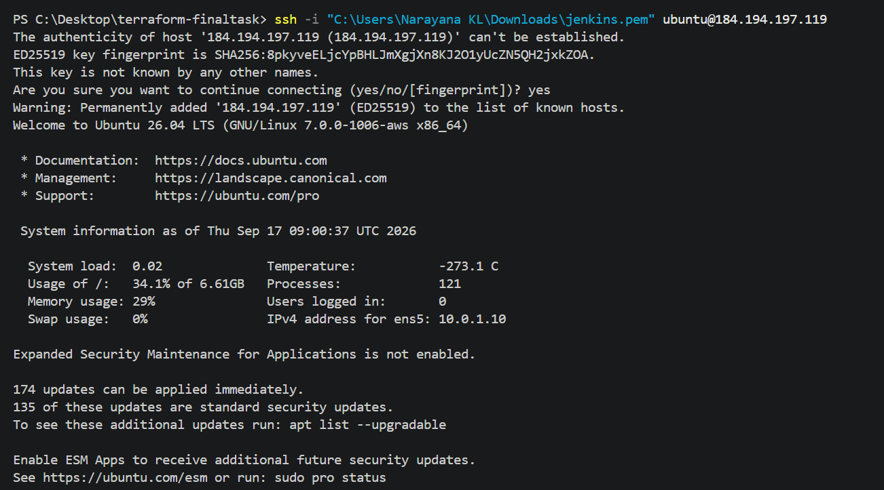
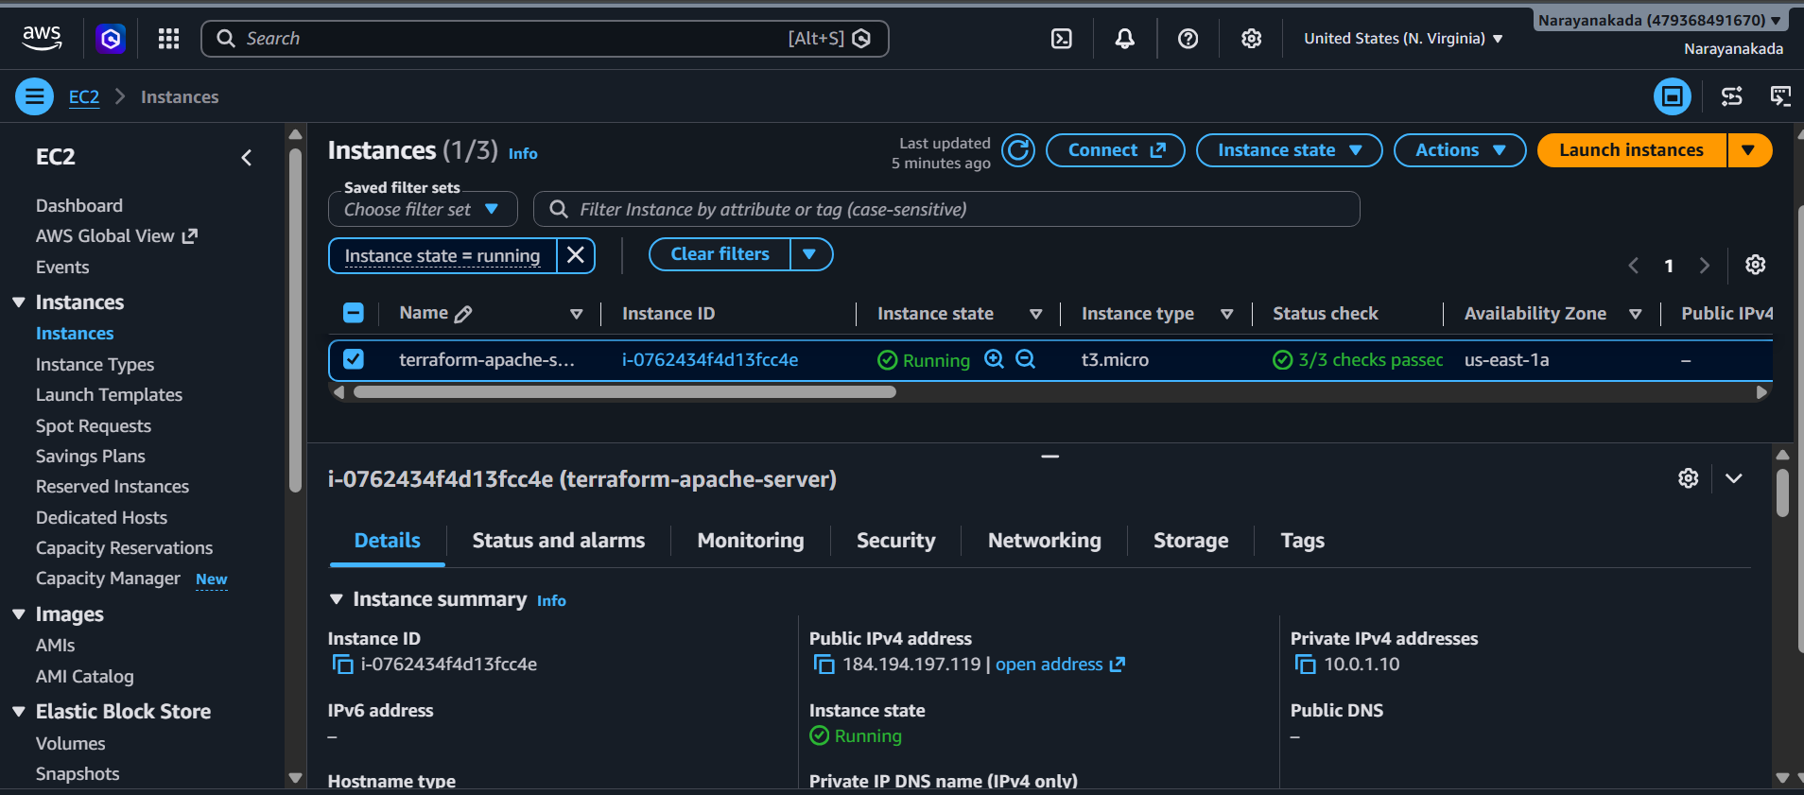
Then: systemctl status apache2
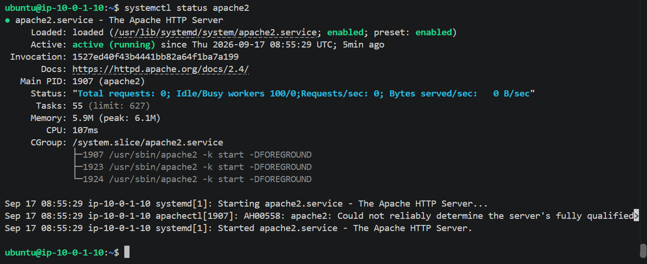
Check Apache: curl http://localhost
Expected: Hello from Terraform Apache Server
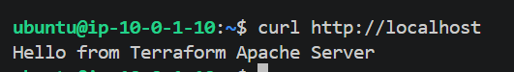
Check Apache server with Elasticip : http://184.194.197.119/
